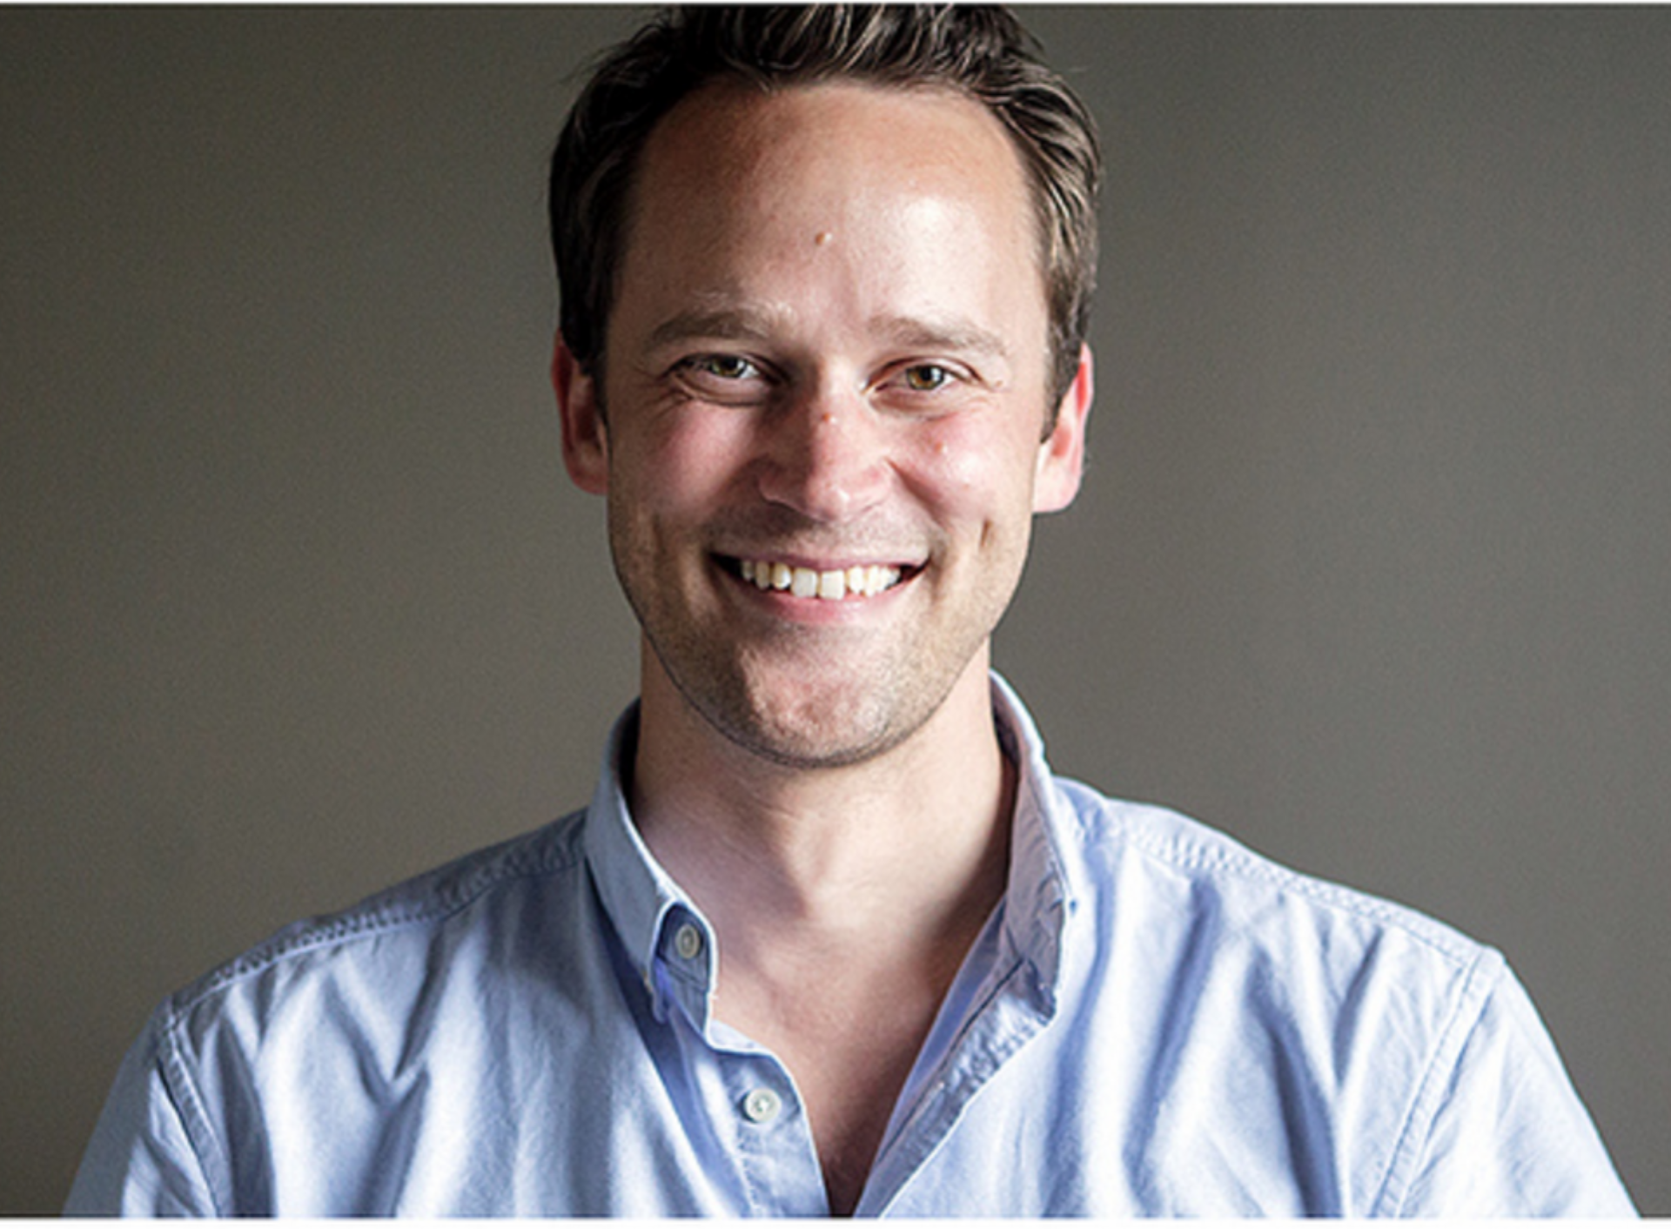Quentin Quire

“Lets see what this thing can do.”

**Age**: 38 **Location**: DTH, MI **Tech Exp**: Medium **Title**: Pod Leader

**About Adam:**

Adam has earned a reputation as a positive, but disruptive force in GE and the technology he represents shows. His reputation is not the result of happenstance, but has been carefully crafted over his six years with GE. Adam is consistently reevaluating his team’s direction and its way of doing things in order to make sure they are always in the right conversations. As a result Adam and his team were selected to be one of the first Pod Teams at the DTH site.

For Adam this is more than just a new job. For him, it is a responsibility to those who he works with to make sure they have every opportunity to succeed within the new GE Digital. This personal stake that he takes in his work and the relationships he builds with his team is the fabric that allows his team to be successful in an ever-changing landscape. The flip side of that personal stake and close relationships is the pressure he feels to succeed. As such, Adam constantly feels the need to make sure he prepared for the next challenge.

With is new position Adam has been given the opportunity to fill several new highly technical roles within his ever-expanding team. While this is an exciting opportunity to continue to build and shape his team, Adam is worried that he will once again struggle to find the talent and personal qualities in a candidate he knows will necessary to be a successful part of his team. He looking to GhostRed as a creative way to possibly attract talent he might not have otherwise been able to reach and evaluate that talent as they work through real-world problems related to what his team does everyday.

Adam is a Computer Information Systems graduate of Wayne State University who loves to keep up with the latest and greatest technology has to offer. A proud father of two, he normally has a project going on at home that he can include his kids in.

**Goals:**

* Looking for a way to attract young, enthusiastic talent who is genuinely interested in the work GE Digital is doing.
* Understand how he can customize GhostRed to attract and evaluate the skills his team needs
* Observe how participants self-form teams and interact as a part of their team
* Evaluate how participants preform against new challenges which test the technical skills he cares most about
* Understand what “Ghosted in a Box” is

**Behavioral Considerations:**

* How participants work is more important than whether or not they win
* Confident in his understanding of the type of talent he wants to attract
* Forward-Thinking people leader who takes a personal state in the success of GE
* In-Touch with how GE is perceived by the external technology community
* Highly organized an detail oriented

**Pain-Points:**

* Not having the information he needs in order to make the preparations he feels are necessary to be successful
* Not seeing tangible benefits from the time and effort he and team spends
* Working against the perception of what GE’s does as company when trying to attract new talent
* Competition against well-established technology companies when recruiting top caliber talent
* Wasting time on a solution that isn’t right for his team and doesn’t result in new valuable recruits

**Needs:**

* Understand how to customize GhostRed to meet his specific needs
* Be able to see that GhostRed is applicable to his perceived use case
* Understand what will be required by his team when hosting a GhostRed Event
* Understand what the GhostRed team provides and is responsible for when putting on an event
* Learn how successful GhostRed has been at attracting new talent who was eventually hired
* Understand how a GhostRed event is run and what participants will do
* Learn how to advertise and attract the right talent to his event
* Have a consistent contact he can work with throughout the process
* Know the cost of putting on an event
* See examples of GhostRed Challenges

Betsy Braddock

“I want to be empowered to make a difference in my day job”

**Age**: 24 **Location**: Atlanta, GA **Tech Exp**: High **Title**: Student

**About Betsy:**

“Prove Them Wrong”; three words that you could almost call Betsy’s internal war cry since she was little. Betsy has always been willing to follow her heart, even if it means going into a field that is normally overrun by white nerdy men. She was drawn to Computer Science through a non-traditional view of what it can achieve. While some might see IT careers as an opportunity to work in a cozy, laid back office environment with unlimited vacation, free drinks and great pay, she sees the potential power of technology to make a difference in the lives of everyday people.

A Computer Science B.S Degree graduate of Perdue who is currently enrolled in the Computer Science Master’s Program at Georgia Tech, Betsy can hold her own in any technical challenge and has the people skills to back it up. She is a rising technical rockstar who has a proven ability to look at problems affecting the world around her and find creative solutions. Most recently she has been partnering with electrical and mechanical engineers at Georgia Tech to create simple robotic utensils to help the physically impaired complete daily tasks such as folding a towel, eating soup with a shaky hand and more.

Betsy loves being a member of a cross-functional team working on challenges that have positive real world implications. Motivated and energetic, she sees herself going to a well-funded startup working on a cutting-edge problem where she would be able to play a major role in deciding the technical and business direction. Betsy has a close network of friends and family back in her hometown in North Carolina, and at Georgia Tech, but is willing to move anywhere for the right opportunity.

**Goals:**

* Find an opportunity to use her technical expertise on a project which will have positive impacts on the world around her
* Work closely with a variety of other expertise in an environment that fosters continuous learning
* Have to opportunity to be innovative and creative without lots of processes and red tape (aka – work in at a company that trusts it’s employees)
* Know what she will be working on at a company in great detail and the type of environment she will be apart of well before she accepts an offer.

**Behavioral Considerations:**

* Betsy isn’t really interested in making money (although a certain amount is expected), but in being able to make a difference.
* Her role model is Tomas Edison “I look for problems in the world around me and proceeded to invent something to fix it.”
* Knows GE’s rich history of innovation and invention, but doesn’t see that reflected in the modern company.
* Doesn’t want to have to move a mountain in order to get something done
* Is familiar with HackerRank & Code Fights and has used them a few times on lazy Sunday afternoons to crush her friends.
* Isn’t really interested in Network Security or Risk, but in creative technical problem solving.

**Pain-Points:**

* Working on mundane, un-meaningful work
* Not feeling like she is able to use her talents to make a positive difference
* Being “trapped” in a position without opportunities to collaborate across expertise.
* Going into a job or event blind
* Working around people who don’t have similar goals, but are more interested in easy money.

**Needs:**

* Strong understanding of GE’s work environment and the impacts of the projects available to open positions at GE.
* 1x1 In-Depth conversations with potential teammates
* Challenging and interesting problems that are worth showing up at an event for
* Being apart of a cross-functional team with opportunities for working across those roles

**Edward Vedder**

“It is all about the Candidate Experience, creating a lasting positive association with GE Digital, regardless of how the hiring decision plays out”

**Age**: 35 **Location**: Boston, MA **Tech Exp**: Mid-Low **Title**: Recuiter

**About Edward:**

For Edward, Recruiting is all about the experience; from the candidate to the hiring manager.  Edward's goal goes beyond just filling open positions to what he affectionately refers to as the "Recruiting Long Game".  Much of Edward's success has come from him Looking beyond the short term results recruiters are often evaluated on and instead playing the long game  For Edward, this means working to create lasting relationships with the IT community in the areas he works through events such as Meet-ups and HackerX.  At these events Edward works hard to create positive associations with GE as a Digital Industrial company with the hopes that top talent will remember GE Digital when it is time for their next career move or someone in their network's next move.  The long game also means working closely with the hiring managers of positions he is working with and seeking out technical talent who will fit those manager's unique requirements.  Edward goes the extra mile for his hiring managers and stays in almost daily contact with them in order to make sure he is doing the best he can to fill their open role.

Edward has seen several shifts in Recruiting strategy since he joined GE 9 years ago.  Most notably he is seeing more open positions for Professional Band employees than he is seeing requests for Senior Engineers.  This shows a shift from hiring managers to watch over contractors to finding rockstar talent who will be able to do innovative work themselves.  In practical terms for his position this means a change in his strategy for connecting with talent. In all his years as a recruiter Edward has also learned that the top talent almost never applies to jobs on job-boards, but they are found through cold calls and messages on LinkedIn.  His challenge with PB talent is getting to them before they are "snatched away" by well known technical powerhouse companies. This being true Edward is always looking for unique ways to make his cold contact attempts stand out from the sea of recruiter spam that top talent receives.

Evaluating technical ability is easy for Edward, generally a quick look at a resume and portfolio can give him a good idea of a candidates abilities.  What is much harder is determining their soft skills; if they will be an outgoing, original idea generator or the person who sits in a dark corner coding their own way without talking to anyone.  He is always excited by the prospect of a new tool which he can use to make lasting positive connections with candidates while also evaluating their technical and personal skills.

Edward is a graduate of the Ross Business School at U of M and is currently leading up the recruiting efforts for two of the major technology hubs in GE.  On the weekends you can find him with his family on the lake either behind a boat on water skis or behind a fishing reel.

**Goals:**

* Connect with Top Talent (Relevant Work Experience/Internships, Good Academic Experience, Strong Soft Skills, Volunteer Work)
* Leave Top Talent with a positive impression of GE regardless of hiring decision outcome
* Create lasting relationships with IT communities where GE is seen as a desirable place to work (Interesting projects, Good Work Environment, Technology Career Path Mobility)
* Get an edge over competitor companies
* Hire top talent

**Behavioral Considerations:**

* Has been in the field long enough that he has learned the value of being willing to play the long game with Top Talent
* Good judge of technical and personal skills, but struggles sometimes to create environments where he has the opportunity to do so
* Willing to work more than the standard 40 hour work week and integrate himself in the local IT community in order to establish the relationships that make him successful in his job

**Pain-Points:**

•  Locating and connecting Top Talent

•  Not having visibility to potentially influencing projects in GE

•  Leaving candidates with a negative experience during/after the hiring process

**Needs:**

•  Something that can make his cold calls/emails stick out as interesting and appealing

•  Avenues for creating relationships with Technical Talent that makes them associate GE with a top tier Digital company

•  Tools to help him locate and evaluate Top Talent who decides to not apply to jobs on job boards

•  To know how he can use GhostRed to achieve his goals with Top Talent